Unit 4: Matter and Energy in the Environment

The Cycling of Matter in the Biosphere
Let's start by discussing what the biosphere actually is. It is thin layer around planet Earth where life exists. It is made up of the air, water and land that life as we know it survives. Within the biosphere, matter is continually cycled and energy flows through different systems in order to maintain homeostasis (a balance) for all living things to survive.

1. Natural Cycles: Food Chains, Food Webs & Energy Pyramids
All living things need energy to survive. This energy is passed through ecosystems from organism to orgranism. Food chains, food webs and energy pyramids show how that energy is passed along.
Food chains: show a single pathway of energy flow in an ecosystem - the arrows represent the direction energy moves in the food chain.
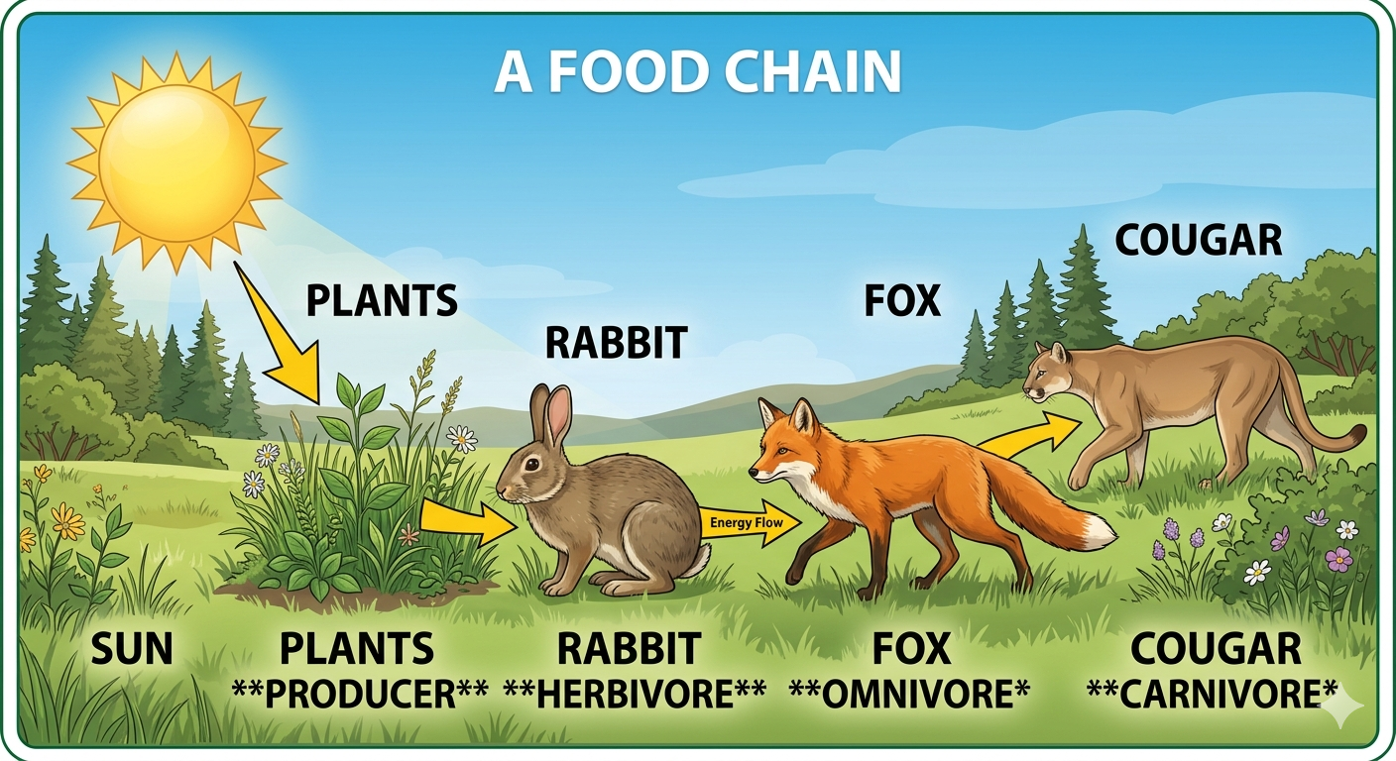
Food webs: interconnected food chains in an ecosystem, showing how organisms depend on each other. These are more accurate representations of ecosystems because organisms feed on more than one type

Forest/Grasslands Food Web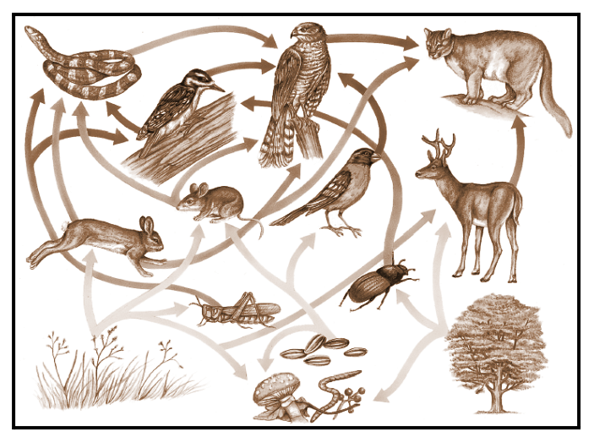
Energy pyramids: show that energy decreases as you move up each level in an ecosystem. It is shaped as a pyramid to illustrate that we MANY producers and herbivores to support a small number of ominvores and carnivores:
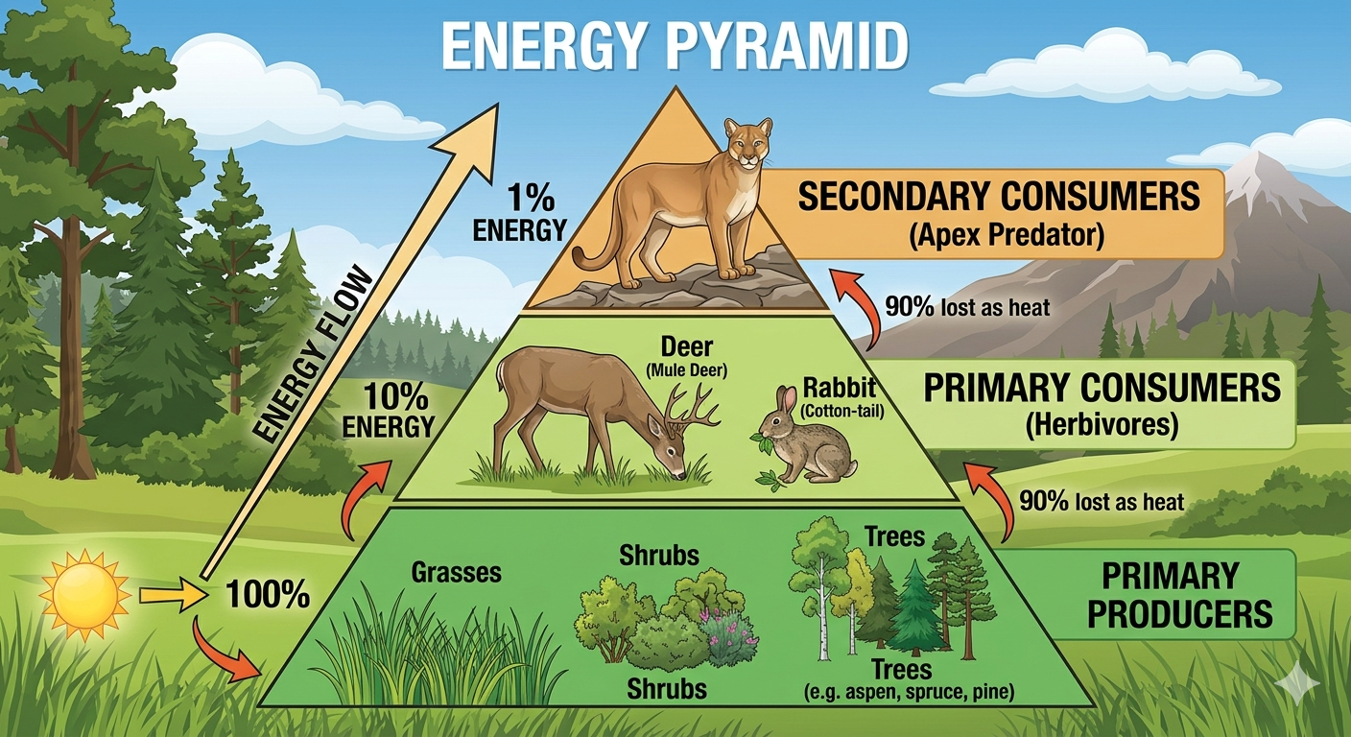
- Producers (plants) capture sunlight.
- Herbivores eat plants.
- Carnivores eat herbivores.
Only ~10% of energy moves to the next level.

2. The Cycling of Matter
Matter such as oxygen (O₂), carbon (C) and water (H₂O) need to be recycled within the biosphere. We will focus on two main systems: The Water Cycle and The Carbon Cycle.
The Water Cycle: All living things need water to survive and Earth has a limited amount. Therefore, water needs be recylced to be used over and over again.
There are 4 key steps to the water cycle:
- Evaporation: liquid water is heated up and changes to gas
- Transpiration: water evaporates from plant leaves
- Condensation: water vapour cools and returns to a liquid
- Precipitation: water droplets join together and fall back to the Earth
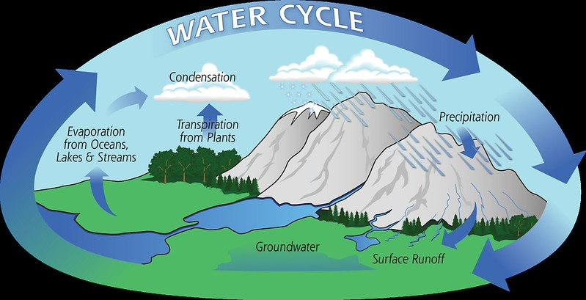
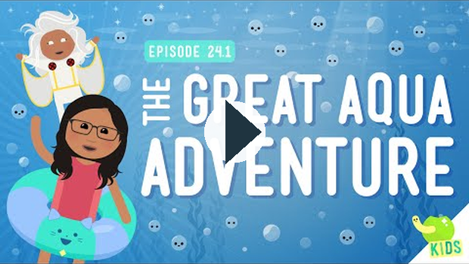
https://www.youtube.com/watch?v=z5G4NCwWUxY
The Carbon Cycle: Carbon is the basic building block of all living organisms on Earth. Everything that is living or has died contains carbon. Producers (plants) take in carbon dioxide (CO₂) through photosynthesis and consumers (animals) release CO₂ through cellular respiration. When humans use fossil fuels such as oil and natural gas, we release the Earth's stored carbon back into the atmosphere.

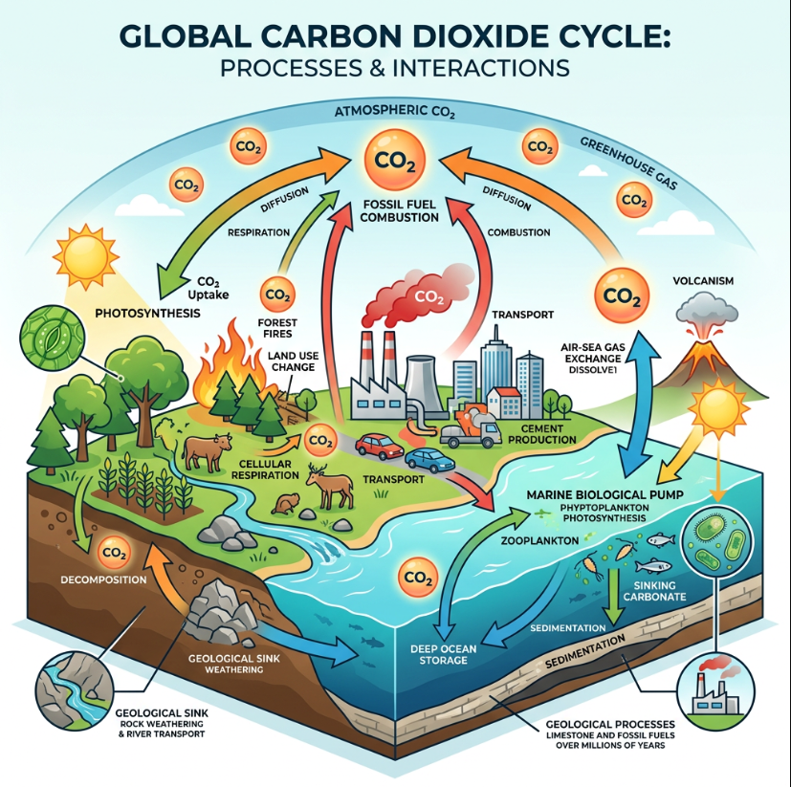

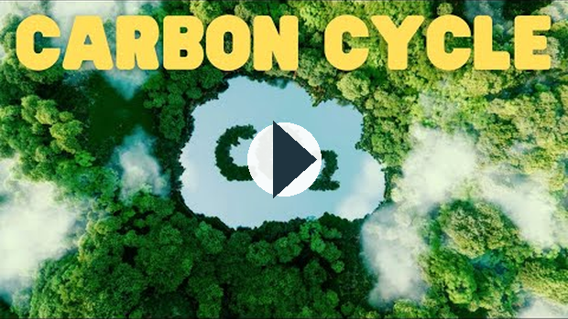
https://www.youtube.com/watch?v=GW-V-jwTLMA

Key Takeaways
The biosphere is a closed system for matter—it recycles through food webs and nutrient cycles.
Human activity can support or disrupt these natural cycles.
Technologies bring benefits, but many have unintended consequences for ecosystems and long-term sustainability.
Looking at traditional knowledge, biodegradable materials, and modern recycling can help us reduce our impact.

Human Influence and Technology
Humans require many resources from the earth in order to meet our basic needs and live our day-to-day lives. With approximately 8.3 billion people on the planet needing food, water, shelter and clean air, we have disrupted the Earth's natural cycles. Let's explore some of the impacts humans have had on the earth and how we are trying to improve our balance with the planet.

1.Human Influence on Natural Cycles
Traditional Aboriginal societies often used sustainable practices in order to live in balance with the land and protect the resources it provided them. Here are a few methods they used:
- Rotating hunting and gathering grounds.
- Using all parts of animals (reducing waste).
- Controlled burns to renew ecosystems.

https://www.youtube.com/watch?v=o30bpI6n8FM
Modern societies often disrupt the planet's natural cycles by:
- Overfishing or overhunting.
- Clearing land for farming and cities.
- Using fossil fuels, which add carbon dioxide to the atmosphere.
- Create more waste than the Earth can recycle.
- Pollution of fresh and saltwater.

2. Costs & Benefits of Technology That Produces Non-Recyclable Materials
Humans consume many, many products every single day. The are often made of plastics, heavy metals, and other synthetic products that don’t break down naturally. These maeterials have pros and cons:
Pros/Benefits | Cons/Costs
- cheap  - strong  - long-lasting  - useful in medicine  - convenient packaging  - easier for transportation | - Pile up in landfills and oceans  - Harm wildlife (e.g., turtles eating plastic bags)  - Enter the food chain as microplastics  - Create pollution when manufacturing the products  - Use non-renewable resources  - One-time use and easy to throw away
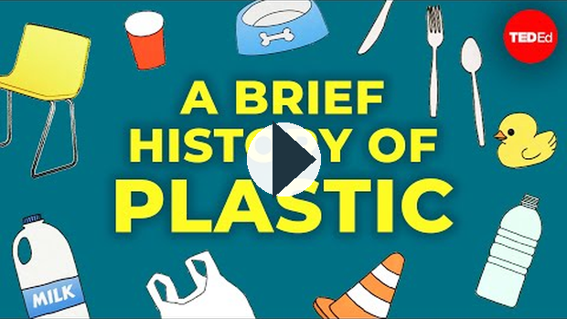
https://www.youtube.com/watch?v=9GMbRG9CZJw

3. Biodegradable Materials
Biodegradable products are materials that (like paper, natural fibers, compostable plastics) can be broken down by bacteria and other decomposers and returned to the earth naturally. They DO NOT not take hundreds of years to break down like plastics and other synthetic matierals and they do not leave behind pollutants. They reduce long-term waste and pollution.
Some examples of biodegradable products are:
- paper
- natural fibres
- compostable plastics
- wood,
- food products
- yard waste.
Check out this video one type of biodegradable product that is trying to provide an alternative to traditional plastic:
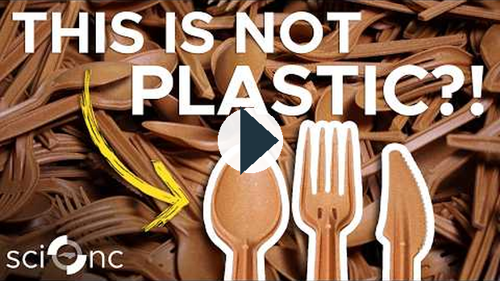
https://www.youtube.com/watch?v=X2C032j22PI

4. Recycling in Society vs. Natural Recycling
We have learned about two of nature's key recycling processes, such as the water cycle and carbon cycle, but we humans also have our system to recycle waste. Although recycling our materials is key to reducing waste and pollution, they are much LESS efficient and require lots of energy when compared to the Earth's natural cycles. Watch the video below to learn about what happens to the materials we send away for recycling.
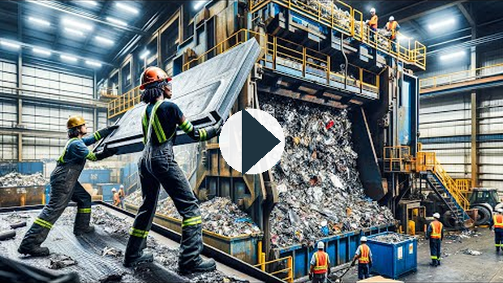
https://www.youtube.com/watch?v=cNPEH0GOhRw

5. Impact of Modern Agriculture
As mentioned earlier in the unit, we have a very large population on Earth and each one of the billions of people that live here need food to survive. Therefore, we rely on agriculture. Agriculture - the growing and harvesting of crops, as well as raising livestock - is key to a healthy population. These plants and animals also provide natural materials like wool, cotten and hides (leather) that are turned into materials we use every day.
Farming practices have changed over the past few decades, relying on more efficient methods and new technology.
Negative Impacts of Agriculture:
- Pesticides & fertilizers disrupt soil and water cycles.
- Monoculture (one crop over large fields) reduces biodiversity.
- Runoff of chemicals → algal blooms → oxygen loss in lakes and rivers.
- Large scale farming produces large amounts of greenhouse gases
Positive Impacts of Agriculture with Changing Methods and Technology:
- Produces larger amount of food for growing population
- Protects the vital soil needed to grow crops and raise livestock
- Regrowth of natural plants
- Increased populations of pollinators such as bees and other insects
- Reduction of current levels of greenhouse gas emissions
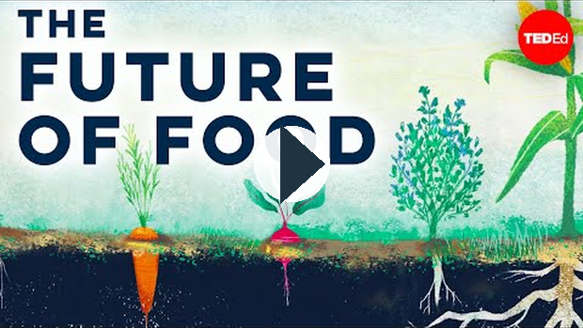
https://www.youtube.com/watch?v=xFqecEtdGZ0

6. Unforeseen Environmental Consequences of Technology
Fishing technology: large nets and factory ships remove fish faster than they can reproduce → collapse of populations.
Pesticides (e.g., DDT): killed pests but also accumulated in food chains, harming birds and other wildlife.
Automobile emissions: add greenhouse gases (CO₂, NOx) → climate change and smog.
Industrial activities: create pollutants ecosystems can’t recycle (plastics, heavy metals).

Key Takeaways
The biosphere is a closed system for matter—it recycles through food webs and nutrient cycles.
Human activity can support or disrupt these natural cycles.
Technologies bring benefits, but many have unintended consequences for ecosystems and long-term sustainability.
Looking at traditional knowledge, biodegradable materials, and modern recycling can help us reduce our impact.

Ecosystems, Biomes and Balance in Nature
All living (biotic) and non-living (abiotic) parts within an ecosystem are connected and depend on one another. As we have learned in the previous two lessons of this unit, ecosystems want to achieve homeostasis and have many processes in place to try and stay balanced.

1. Ecosystem Components
An ecosystem is any area in the environment where living and non-living things interact. Ecosystems can be vast like a coral reef or small area like a rotting tree stump. Let's look at some examples of living (biotic) and non-living (abiotic) factors within an ecosystem.
Biotic (living) | Abiotic (non-living)
- plants  - animals  - fungi  - micro-organisms | - soil  - air  - water  - sunlight  - temperature
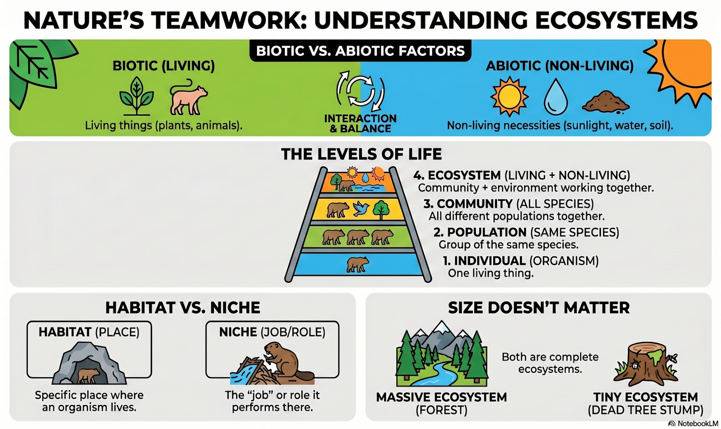
How Abiotic Factors Shape Life: Even though the abiotic parts of an ecosystem are not alive, they determine which organisms can stay alive.
1.Temperature - The Thermostat of Life: Most living things can only survive within a certain temperature range. Temperatures that are too high or too low can destroy cells and proteins necessary for life.
- Example - Evergreen trees have thick, waxy needles to survive in -30ºC
2.Altitude - Life on the Mountain: Altitude is how high up you are (elevation). As you go higher up in the Rocky Mountains there is less oxygen and the air is cold.
- Example - mountain goats have thick fur and special hooves to survive in the harsh mountain environment
3. Climate - The Big Picture: Climate is the average weather pattern of temperature and precipitation. Hot and dry climates cannot support big forests, while cooler areas with lots of rain/snow allow massive forests of spruce and pine trees.
- Result - since the producers (plants) are at the beginning of every food chain, they determine which animals can live there to eat those plants.

2. Alberta Biomes
What is a biome? A biome is a group of similar ecosystems with the same general abiotic factors such as climate, soil and topography. These abiotic parts of the biome allow certain types of plants and animals to survive. We are going to examine Alberta's 6 major biomes.
Image below from: https://naturealberta.ca/ecosystems/
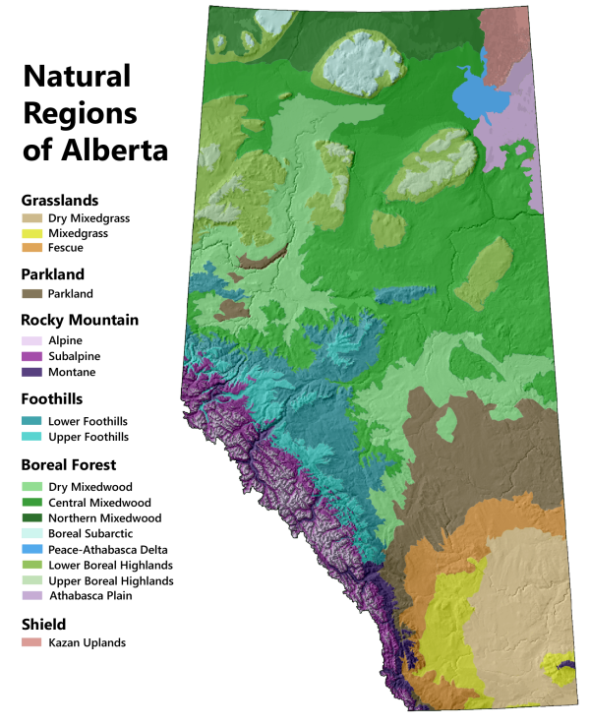
Watch the following video for a tour of Alberta's 6 major biomes:

../02_SUPPORTING_FILES_BY_UNIT/Linked Media/Lesson 3 - Ecosystems, Biomes,-47e9631748.mp4

3. Changes in Populations
There are many factors that influence the populations of plants and animals within an ecosystem and they are very sensitive to change. A healthy ecosystem keeps the populations of plants and animals in an optimal range. This means that there aren't too many or too few of certain organisms within the habitat.
Two major factors that INCREASE the size of a population are:
- Birth Rate - The number of organisms that are born within a certain period of time.
- Immigration - The number of organisms that join a population.
Two major factors that DECREASE the size of a population are:
- Death Rate - The number of organisms that die within a certain period of time.
- Emigration - The number of organisms that leave a population.

4. Limiting Factors on Population
Anything in an ecosystem that increases or decreases the size of a population is called a limiting factor.
Limiting Factor | Definition | Examples
Biotic | Interactions among living organisms | - competition  - predation  - parasitism
Abiotic | Non-living parts of the physical environment | - water  - temperature  - sunlight  - nutrients

https://www.youtube.com/watch?v=COUCeXQcKgw
What exactly are factors such as competition, parasitism and predation? Watch the following......
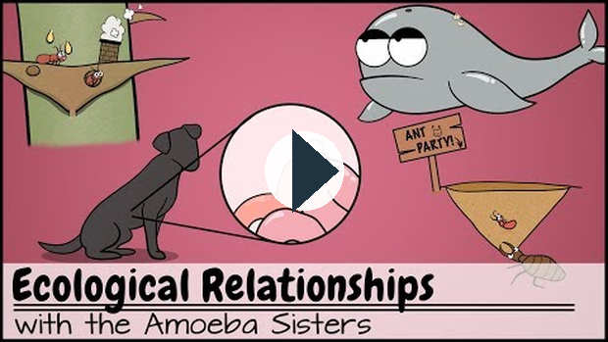
https://www.youtube.com/watch?v=rNjPI84sApQ

5. Changing Ecosystems and Environmental Laws
Humans are constantly making changes to our ecosystems, some are positive and some are negative. Canada and Alberta have put laws and restrictions in place to help protect and minimize damage to our ecosystems. The table below has 3 examples.
Human Impact on Ecosystems | Federal Law (Canada) | Alberta Provincial Law | How it Protects the Environment
Climate Change & Air Pollution (Burning fossil fuels, industrial emissions) | Canadian Environmental Protection Act (CEPA) | Technology Innovation and Emissions Reduction (TIER) | Sets strict limits on toxic air pollutants and requires large industries to pay for or reduce their carbon emissions.
Water Contamination (Industrial runoff, tailings ponds, sewage) | Fisheries Act | Environmental Protection and Enhancement Act (EPEA) | Makes it illegal to release "deleterious substances" (poisons) into water where fish live and regulates factory discharge.
Habitat Loss & Biodiversity (Urban sprawl, mining, deforestation) | Species at Risk Act (SARA) | Wildlife Act & Alberta Land Stewardship Act | Protects the "critical habitat" of endangered species (like the Woodland Caribou) and plans how much land can be developed.

